Chapter 3 Exercises

**Minimum**

function min(x, y) {

if (x > y)

return y;

else

return x;

}

console.log(min(0, 10));

// → 0

console.log(min(0, -10));

// → -10

**Screenshot of the solution**

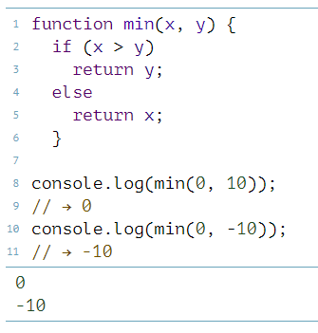

**Recursion**

function isEven(wNum){

if (wNum == 0) {

return true;

} else if (wNum == 1) {

return false;

} else if (wNum < 0) {

return isEven(wNum * (-1));

} else {

return isEven(wNum - 2);

}

}

console.log(isEven(50));

// → true

console.log(isEven(75));

// → false

console.log(isEven(-1));

// → ??

**Screenshot of the solution:**

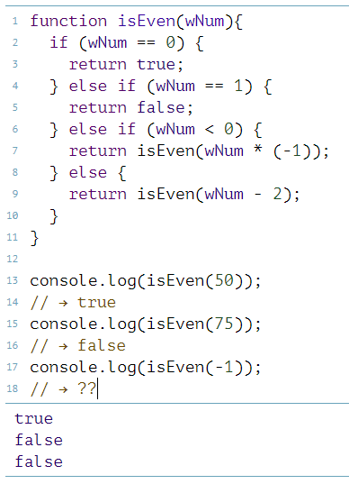

Bean Counting

function countBs(word){

let count = 0;

for (let i = 0; i < word.length; i++){

if (word[i] == "B"){

count += 1;

}

}

return count;

}

function countChar(name, letter){

let count2 = 0;

for (let i = 0; i < name.length; i++){

if (name[i] == letter){

count2 += 1;

}

}

return count2;

}

console.log(countBs("BBC"));

// → 2

console.log(countChar("kakkerlak", "k"));

// → 4

**Screenshot of the solution:**

